Sean calls the meeting to order at 6:50pm and we begin with the Serenity Prayer. Andrea reads and reviews the 3rd Tradition. Jeri reads and reviews the 3rd Concept. Reps go around the room and introduce themselves.

There were:
- 17 Attendees at peak
- 1 New Member - Robin
- 16 Voting members
- 5 Board members

A quorum is established.

Minutes

Sean notifies Intergroup that we will vote on February minutes during New Business.

Committee Reports

#1: Sunny gives the Finance Report (attached)
#2: Erin gives the Special Events Committee Chair Report (attached)
#3: Barbara gives Retreat Committee Chair Report (attached)
#4: Sasha gives the Outreach Committee Chair Report (attached)
#5: Hannah gives a Publication Committee Chair Report (attached)
#6: Liz gives the Web Committee Chair Report (attached)
#7: JP gives the Bylaws Committee Chair Report (attached)

Pending Business

#1: The 7th Tradition is collected.

New Business
#1: Sean speaks on the COVID-19. Check oanyc.org for meeting cancelations.
#2: Erin suggested possibly posting on oanyc.org bulleted suggestions for points meeting regarding COVID-19. The board agrees.
#3: Sean reads the qualifications for the Region 6 representative position that is available. Sasha is appointed as the new Region 6 Rep.
#4: Scott makes a motion to accept the February minutes. Sasha seconds the motion. February minutes are approved.
#5: Sasha shares a highlighted oa.org document “Intergroup Inventory”
#6: Hanna agrees to share a highlighted oa.org document.
#7: Erin and JP agree to be our GoogleVoice volunteers
#8: Sasha agrees to read 4th Tradition
#9: Andy agrees to read 4th Concept.
#10: Andy makes a motion on behalf of the Finance Committee that we allocate $6,500.00 from the Retreat Committee to the Special Events Committee for the upcoming Summer Camp Event. Jeri seconds the motion. Pro’s and cons are heard. The motion passes.

Announcements

#1: Sarah announces that we have collected $35.00 in 7th tradition contributions.

Wrapping Up
Meeting closes at 7:51 pm with the OA pledge and the serenity prayer.
Committee Reports:

Position | Person | Email Contact
Chair | Sean B. | Chair@oanyc.org
Vice Chair | Sarah WB | ViceChair@oanyc.org
Treasurer & Finance | Sunny W. | Finance@oanyc.org  Treasurer@oanyc.org
Corresponding Secretary | Andy P. | CorrespondingSecretary@oanyc.org
Recording Secretary | Heather M. | RecordingSecretary@oanyc.org
Archives Committee Chair | OPEN | Archives@oanyc.org
Bylaws Committee Chair | JP M. | Bylaws@oanyc.org
Outreach Committee Chair | Mollie S-G | Outreach@oanyc.org
Publications Committee Chair | Hannah P. | Publications@oanyc.org
Retreat Committee Chair | Barbara S. | Retreat@oanyc.org
Special Events Committee Chair | Erin B. | SpecialEvents@oanyc.org
12th Step Within Committee Chair | Rebecca B. | TwelfthStepWithin@oanyc.org
Web Committee Chair | Liz D. | WebCoordinator@oanyc.org
3 Year Trustee | Andy P. | ThreeYearTrustee@oanyc.org
1-Year Trustee A: | Rebecca B | OneYearTrustee@oanyc.org
1-Year Trustee B: | Mollie S-G | OneYearTrustee@oanyc.org

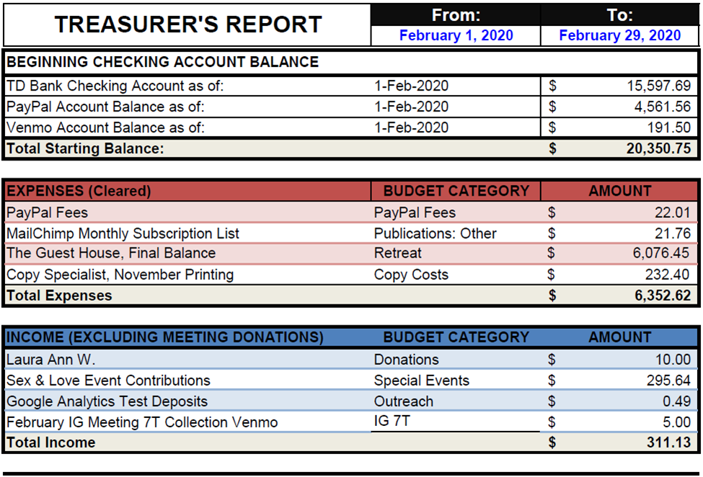

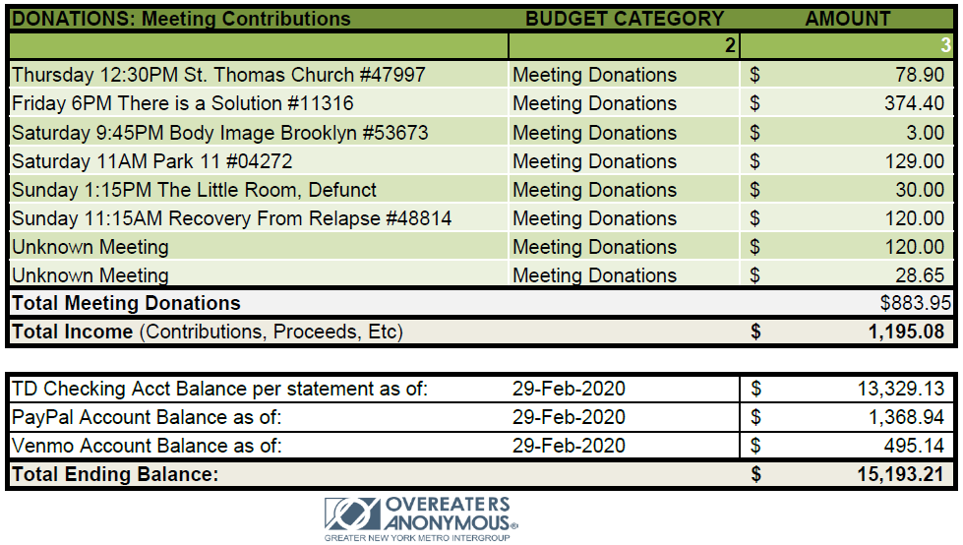

Did you know that according to WSO, "OA is not only self-supporting through its own contributions; it also must rely on literature sales to help carry the message," —WSBC 2015 (Ask It Basket)? In addition they also explain that, "our profit margin is much lower with electronic sales, as sales prices are governed by e-book vendors.” —WSBC 2016 (Ask It Basket). In order for us to adhere to the Traditions, all literature that is purchased for a registered group, service body or event sponsored by Metro IG should be made through the OA WSO Book Store. Purchasing literature from third party vendors, including online retailers and local book stores which may carry our literature is discouraged. Those purchases do not allow us to practice our Seventh Tradition as the monies do not go towards OA directly. Please pass this information along to your Literature reps at meetings, and consider including this information in the service description for your Literature Reps in your individual meetings.

Publications Committee Chair Report/Hannah P: This month the committee prepared the hard copy of the March Metro Memo. It is now available! We also sent out a blast for the Love and Sex in Recovery Event, which had a 39.5% open rate. The Metro Memo for February had a 22.1% open rate. The Meeting List is also being updated as changes are sent in through the website. We will send out the PDF of March Metro Memo and updated meeting list to the email list. This month the committee will prepare the April Metro Memo, which will be an email, and will send out a blast for the Recovery Clothing Swap. The publications committee would love your submissions, artwork, or games to include in the digital and hard copy Metro Memos! Please contact publications@oanyc.org to get involved!

Special Events Committee Report/Erin B: The last Special Event was the Sex & Love in Recovery event on 2/23 and was a huge success! We had about 60 attendees and made $300! What sparked from that event was an idea for a "Improving Relationships with Friends, Family & Co-Workers Through the Traditions!" Event. Maybe next year! :) The next Special Event will be held on April 12th from 2-5pm. The OA Recovery Clothing Swap will be at 4thU and we're looking for a couple volunteers with cars to take the leftover clothes/accessories to a donation drop-off in the city. All donations need to be brought day-of and can not be dropped off early or after 5pm. The BIG event coming in May is a joined effort by the Special Events Committee and the Twelve-Step Within Committee. We will be holding an OA City Summer Camp at the Hilton in Midtown, Times Square (thank you, Rebecca!!) on May 30-31st. Registration is $100 per person and does not include a hotel room or food. The event is being designed like a mini-convention and a retreat, combined! 19 meetings, 4 Keynote speakers, 4 workshops, yoga/meditation and, of course, a Talent Show! If you want to be involved in the planning, please email specialevents@oanyc.org. The next Virtual SPEV meeting will be on Tuesday, 3/17 at 5pm online.

Web Committee Chair Report/Liz D: The web site is looking good and running smoothly. Google voice, updates with Tom, and correspondence with fellows/intergroup members have been going fine. I have not gotten any feedback on the site since about October which I am taking as "all is well". Seeing the weekly Google Analytics has been very interesting to see each week. I was surprised to see how much of our traffic is new visitors and I think closer study and analysis of these numbers could be useful in setting committee goals or prioritizing info on our site in the future. In the spring, the committee will be working on documenting how to perform monthly tasks. So far that project is just in the brain storming phase. In the spring, the committee will be working on documenting how to perform monthly tasks. So far that project is just in the brain storming phase. Please let fellows know we would love to hear any ideas or opportunities they see with the site. Also, as always, please continue to send along any meeting updates and they will be added to the home page right away.

Retreat Committee Chair Report/Barbara S: The retreat committee met after the last IG mtg to review the reasons for the financial loss from the 2020 retreat. It was decided that the primary factor was the cost of the rooms at the Guest House & we agreed to review our contractual relationship with GH to determine if something might be changed to improve outcomes in the future and also to investigate other site options. We are currently working on reviewing all the details of our current contract & will continue to analyze possibilities to present to IG for next month’s mtg. As for alternative locations, we have not yet found a suitable venue thus far—eg, at one place there were not enough rooms to accommodate our group, and another had several cottages spread out over the grounds rather than a single building (like the one at GH) large enough for our group and had no private bathrooms either. We welcome suggestions from IG for other sites to consider.

