Sean calls the meeting to order at 6:46pm and we begin with the Serenity Prayer. Alyssa reads and reviews the 2nd Tradition. Sean reads and reviews the 2nd Concept. Reps go around the room and introduce themselves.

There were:
- 19 Attendees at peak – Julie, Naomi, Caroline
- 3 New Members
- 18 Voting members
- 3 Board members

A quorum is established.

Minutes

Sean notifies Intergroup that we will vote on January minutes during New Business.

Committee Reports

#1: Erin gives the Special Events Committee Chair Report (attached)
#2: Barbara gives Retreat Committee Chair Report (attached)
#3: Mollie gives the Outreach Committee Chair Report (attached)
#4: Heather gives a Publication Committee Chair Report (attached)
#5: Sean gives a the Web Committee Chair Report (attached)

Pending Business

#1: The 7th Tradition is collected.

New Business
#1: Jeri makes a motion to accept the January minutes. Belen seconds the motion. January minutes are approved.
#2: Jeri makes a motion to extend Erin’s Region 6 delegate position for 1 years’ time in order for her to fulfill her IGOR Chair Committee Position. Motion passes.
#3: Vote is taken on Proposal Item A. Vote carries.
#4: Vote is taken on Proposal Item D. Vote does not carry.
#5: Vote is taken on Proposal Item B. Vote carries.
#6: Vote is taken on Proposal Item C. Vote carries.
#7: Vote is taken on Proposal Item E. Vote carries.
#8: Vote is taken on Proposal Item F. Vote does not carry.
#9: Vote is taken on Proposal Item G. Vote carries.
#10: Vote is taken on Proposal Item H. Vote does not carry.
#11: Vote is taken on Proposal Item I. Vote does not carry.
#12: Vote is taken on Proposal Item J. Vote carries.
#13: Vote is taken on Proposal Item K. Vote carries.
#14: Vote is taken on Proposal Item 1. Vote carries.
#15: Vote is taken on Proposal Item 2. Vote does not carry.
#16: Vote is taken on Proposal Item 3. Vote does not carry.
#17: Vote is taken on Proposal Item 4. Vote carries.
#18: Vote is taken on Proposal Item 5. Vote carries.
#19: Vote is taken on Proposal Item 6. Vote carries.
#20: Vote is taken on Proposal Item 7. Vote carries.
#21: Vote is taken on Proposal Item 8. Vote carries.
#22: Vote is taken on Proposal Item 9. Vote carries.
#23: Vote is taken on Proposal Item 10. Vote carries.
#24: Erin moves that the Retreat Committee and the Metro IG Treasurer work together to secure a location and budget for the 2021 winter. Motion was seconded. Concerns were raised if this would be a change to the bylaws. Sean motions that the original motion be tabled until the March meeting. Motion passes.
#25: Jeri shares a highlighted oa.org document “How to Start a Meeting of Overeaters Anonymous”
#26: Sasha agrees to share a highlighted oa.org document.
#27: Andrea agrees to read 3rd Tradition
#28: Jeri agrees to read 3rd Concept.
#29: Sasha and Heather agree to be our GoogleVoice volunteers.

Announcements

#1: Sarah announces that we have collected $41.00 in 7th tradition contributions.
#2: Sasha makes a suggestion to highlight the bylaws in the newcomer orientation.

Wrapping Up
Meeting closes at 8:15 pm with the OA pledge and the serenity prayer.
Committee Reports:

Position | Person | Email Contact
Chair | Sean B. | Chair@oanyc.org
Vice Chair | Sarah WB | ViceChair@oanyc.org
Treasurer & Finance | Sunny W. | Finance@oanyc.org  Treasurer@oanyc.org
Corresponding Secretary | Andy P. | CorrespondingSecretary@oanyc.org
Recording Secretary | Heather M. | RecordingSecretary@oanyc.org
Archives Committee Chair | OPEN | Archives@oanyc.org
Bylaws Committee Chair | JP M. | Bylaws@oanyc.org
Outreach Committee Chair | Mollie S-G | Outreach@oanyc.org
Publications Committee Chair | Hannah P. | Publications@oanyc.org
Retreat Committee Chair | Barbara S. | Retreat@oanyc.org
Special Events Committee Chair | Erin B. | SpecialEvents@oanyc.org
12th Step Within Committee Chair | Rebecca B. | TwelfthStepWithin@oanyc.org
Web Committee Chair | Liz D. | WebCoordinator@oanyc.org
3 Year Trustee | Andy P. | ThreeYearTrustee@oanyc.org
1-Year Trustee A: | Rebecca B | OneYearTrustee@oanyc.org
1-Year Trustee B: | Mollie S-G | OneYearTrustee@oanyc.org

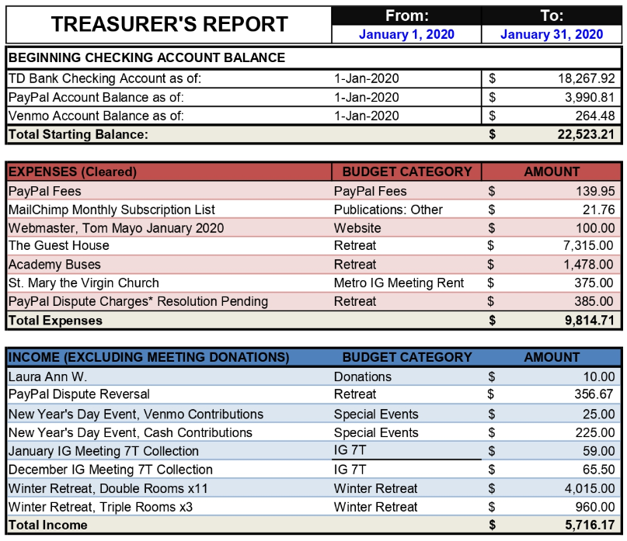

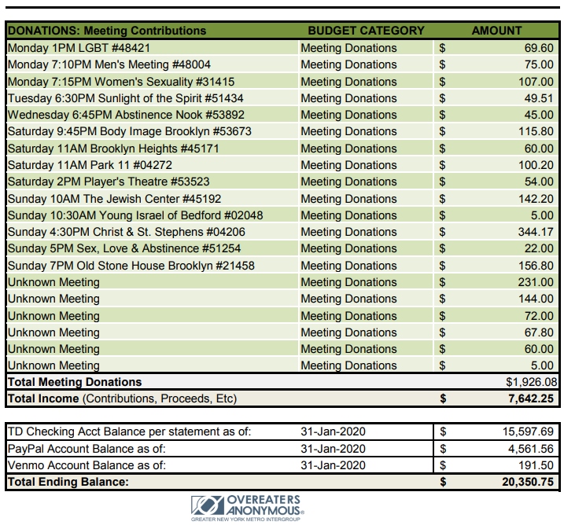

Publications Committee Chair Report/Hannah P: We sent out the Metro Memo on January 10. It had a 25% open rate, which was less than December's memo. No blasts for events were sent. Publications will send out the February Metro Memo on Friday, February 14. We will also continue to coordinate event blasts with the special events chair. The March Metro Memo will be a hard copy, and we are looking for submissions! The publications committee would love your submissions, artwork, or games to include in the digital and hard copy Metro Memos! Please contact publications@oanyc.org to get involved!

Outreach Committee Chair Report/Mollie S: This month the committee met and discussed the next steps for the google ads and the community health fairs we plan to participate in this year. We also created the google ad account and are currently in communication with the webmaster Tom Mayo about how to link this with the google analytics we have gathered in the past so that we can compare website traffic before and after the ads launch and determine the effectiveness of the Google ads.
Next month we will launch the google ads and register for various community health fairs including the BlackVeg fest which we participated in last August. If you’d like to get involved in outreach or have any questions please email outreach@oanyc.org
Special Events Committee Report/Erin B: Our next event will be in February along the lines of Valentine's Day - Sex & Love in Recovery: Practicing the Traditions in Bed! On Sunday, February 23rd from 2:30pm-4:30pm at the Fourth Universalist Society on 76th and Central Park West. (This event is also going to be organized in LA soon!)
Following this will be a Spring Cleaning event on Sunday, April 12th, 2pm-5pm at 4thU - A Relapse Clothing Swap for all genders and all sizes! Bring your gently used clothing and accessories, $10 donation, shop for free, and we'll donate anything not taken! The committee is looking for a couple of drivers with cars and suggestions for drop-off locations open after 6pm on Sundays.
Both upcoming events are listed on oa.org and oanyc.org.
In the summer months, date is TBD, the Special Events Committee will be partnering with the Twelve-Step Within Committee to host an OA City Summercamp over a weekend in NYC! The format will be a mix between a retreat and a convention!! More info to come!!
Our next virtual Special Events Committee meeting will be on Tuesday, February 18th @ 5pm. Email specialevents@oanyc.org if you'd like to attend virtually!

Web Committee Chair Report/Liz D: There was not a lot happening for the committee this month. All the basic activities were done. The info on the site is all up to date. Anticipated actions are adding the clothing swap flyer and the finding out how to add the new Metro Memos to the site. No action was taken on that so far, apologies for the slow movement on that. There will be a new size requirement for banner flyers soon. I will let everyone know when I find out the info on that. Tom has done some great work on the site in the last month. He fixed the banner that was messed up and updated the icons- thank you Tom!

This month we will find out the new requirements for the banner, request one of the meeting minutes sections be removed, and find out how to add new Metro Memos.
Please ask fellows at your meetings to send any feedback on the site too webcoordinator@oanyc.org.

Retreat Committee Chair Report/Barbara S: The retreat went very well with no glitches to report. We had 50 people register and 49 showed up; furthermore, almost everyone attended every meeting during the weekend—something that doesn’t always happen. Feedback—both in person and in the completed evaluation forms—was very positive. Unfortunately, despite the good reviews, the retreat did not make any money. In fact, we lost almost $980. We believe this loss might have been due to the increased cost of both The Guest House rooms & the chartered bus. There are also limitations on just how much we were able to charge registrants, our sole source of income. At this time, IG will need to rethink whether the benefits of hosting the retreat are sufficient to counterbalance the money loss. It is clear that the retreat (at it’s current cost) is not going to be a money maker for IG moving forward. We also need to decide whether we should to find another, less costly site for future retreats. Alternatively, since IG does not provide a budget to the Retreat committee to support the retreat, we may need to change the way we fund this activity.

