Sean calls the meeting to order at 6:45pm and we begin with the Serenity Prayer. Erin B. reads and reviews the 12th Concept. JP reads and reviews the 12th Tradition. Reps go around the room and introduce themselves.

There were:
- 17 Attendees at peak
- 16 voting members
- 5 Board members

A quorum is established.

Minutes

Sean notifies Intergroup that we will vote on November minutes during New Business.

Committee Reports

#1: Sunny gives the Finance Committee Chair Report (attached)
#2: Erin gives the Special Events Committee Chair Report (attached). Diana brought up concerns regarding the “Sex & Love in Recovery” event.
#3: Liz gives the Web Committee Chair Report (attached)
#4: Barbara gives Retreat Committee Chair Report (attached)
#5: Hannah gives a Publication Committee Chair Report (attached)
#6: Sunny gives the 12th Step Within Committee Chair Report (attached)
#7: Liz gives the Outreach Committee Chair Report (attached)
#8: JP gives the Bylaws Committee Chair Report

Pending Business

There was no pending business.

New Business

#1: Sarah makes a motion to accept the November minutes. Alesandra seconds the motion. November minutes are approved.
#2: Reflecting on 2019 Sean asks for feedback and suggestions.
- Erin suggests creating a more stream lined Intergroup info flyer to take back to meetings to develop more interest. Also suggests the possibility of having an OA meeting prior to the Metro IG to boost intergroup involvement.
#2: The 7th Tradition is collected.
#3: Liz agrees to share a highlighted oa.org document in January.
#4: Jerry and Kaitlin agree to be our Google Voice volunteers.
#5: Heather agrees to read 1st Tradition.
#6: Andy agrees to read 1st Concept.

Announcements

#1: Andy announces that we have collected $65.50 in 7th tradition contributions. Sunny confirms.

Wrapping Up
Meeting closes at 7:38pm with the Serenity Prayer.
Committee Reports:

Position | Person | Email Contact
Chair | Sean B. | Chair@oanyc.org
Vice Chair | Sarah WB | ViceChair@oanyc.org
Treasurer & Finance | Sunny W. | Finance@oanyc.org  Treasurer@oanyc.org
Corresponding Secretary | Andy P. | CorrespondingSecretary@oanyc.org
Recording Secretary | Heather M. | RecordingSecretary@oanyc.org
Archives Committee Chair | OPEN | Archives@oanyc.org
Bylaws Committee Chair | JP M. | Bylaws@oanyc.org
Outreach Committee Chair | Mollie S-G | Outreach@oanyc.org
Publications Committee Chair | Hannah P. | Publications@oanyc.org
Retreat Committee Chair | Barbara S. | Retreat@oanyc.org
Special Events Committee Chair | Erin B. | SpecialEvents@oanyc.org
12th Step Within Committee Chair | Rebecca B. | TwelfthStepWithin@oanyc.org
Web Committee Chair | Liz D. | WebCoordinator@oanyc.org
3 Year Trustee | Andy P. | ThreeYearTrustee@oanyc.org
1-Year Trustee A: | Rebecca B | OneYearTrustee@oanyc.org
1-Year Trustee B: | Mollie S-G | OneYearTrustee@oanyc.org
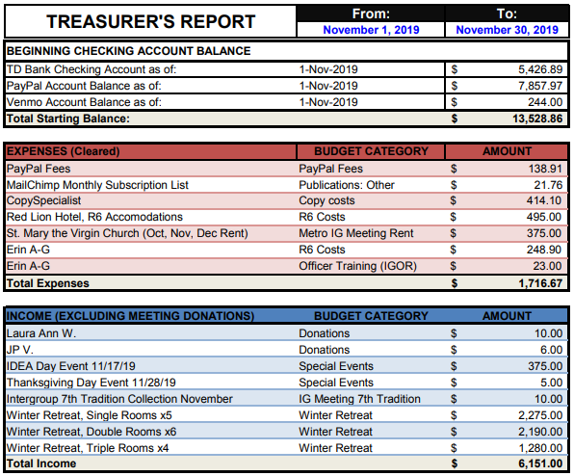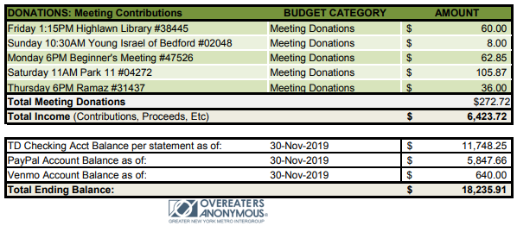

Publications Committee Chair Report/Hannah P: This month the publications committee sent out the November Metro Memo and reminders for the IDEA Day Workshop and Thanksgiving Marathons. The Memo had 25% opens, IDEA day had 37.5% opens, and Thanksgiving Day has 28% opens. These numbers are about the same as previous campaigns. We have a hard copy of the December Metro Memo! Please take and distribute at your meetings! This month, publications will send out reminders for the Relapse and Recovery event and New Years Day Marathon. Publications will also put together a digital Metro Memo for January. Please contact publications if you'd like to contribute writing or art to future memos.

Special Events Committee Report/Erin B: The committee is full steam ahead for events over the holidays! The IDEA Day event with a theme of Abstinence vs. Plan of Eating was a huge success! We made $375 and I put together an extensive timeline of OA. This timeline is going to be digitized and offered to WSO for the oa.org website.
Thanks to Debbie and all those who were of service to make the Thanksgiving Day Marathon a success! We made $114!
Our next event will be a Relapse from Recovery event on Sunday, December 15th from 2:30pm-4:30pm at the 4thU church. We will have great speakers, fantastic OA suggestions for dealing with relapse and ways to support those going through it.
Following December, our special event will be A New Year's Day Marathon at the Fourth Universalist Society on 76th and Central Park West from 1pm-4pm. The event will be in the gym, down 2 flights of stairs and there is no elevator.
After that will be an event in February along the lines of Valentine's Day - Sex & Love in Recovery: Practicing the Traditions in Bed! On February 23rd from 2:30pm-4:30pm at the Fourth Universalist Society on 76th and Central Park West. These 2 events will be planned at our next virtual Special Events Committee meeting on Tuesday, December 17th @ 5pm. Email specialevents@oanyc.org if you'd like to attend virtually!

Web Committee Chair Report/Liz D: The basics have all been covered this month. The google voice volunteers were updated, all the meeting minutes are up to date, and the latest meeting list is on the site. All meeting alerts have been listed as well. Currently I am have identified three goal that I would am either currently or will be soon, working on with Tom. They are to make the mobile site have our name displayed properly, to fix the calendar link, and to move the minutes link to the proper place/fix the secondary minutes link. Please ask fellows to email the web committee if they notice any problems on the website or if they would like to have information posted.

Retreat Committee Chair Report/Barbara S: The Guesthouse contract obligates us to guarantee 35 people for the retreat (although we are hoping to have more than that attend). As of 12/9/19, we have 29 people signed up with an addition 3 people named as roommates but who have not yet registered. I will be sending the original people who registered a reminder that they need to contact their intended roomies and urge them to register.

12 Step Within Committee Chair Report/Rebecca B:
1. Distribute this OANYC Speaker List to meetings that have a Speaker Format.
2. Get More Speakers onto the List. Please announce at any OANYC meeting: OANYC welcomes more speakers to add themselves to the list.

How to Submit Speaker Details (for new speaker, corrections, or deletions): Please use the ONLINE FORM that appears on OANYC.org.

To find speaker list information and the Form:
On a desk top computer, go to “Meeting Info” tab then “Making Speaker List Change.”
On mobile, go to “To Our Current Fellows”, then “Looking for a Meeting.”

Outreach Committee Chair Report/Mollie S: This month the committee has been considering how to utilize the increased budget allocated by Intergroup at the last meeting. We plan to use some of that budget to launch text-only Google ads using language from OA approved materials. Our goal is to launch the ads by January 1st since many people look to address their eating and weight concerns during the New Year. We have also discussed utilizing some of our budget to do other outreach events that align with the strategic goals of IG, namely reaching out to more diverse populations than are currently represented in OA. Next month we will be finalizing our budget, choosing specific outreach events to pursue and hopefully launching the Google ads in the New Year! If you’d like to get involved in outreach or have any questions please email outreach@oanyc.org.

