Sarah calls the meeting to order at 6:48pm and we begin with the Serenity Prayer. Heather reads and reviews the 1st Tradition. Andy reads and reviews the 1st Concept. Reps go around the room and introduce themselves.

There were:
- 21 Attendees at peak
- 2 New Members
- 20 Voting members
- 4 Board members

A quorum is established.

Committee Reports

#1: Erin gives the Special Events Committee Chair Report (attached)
#2: Andy gives the Finance Committee Chair Report (attached)
#3: Barbara gives Retreat Committee Chair Report
#4: Hannah gives a Publication Committee Chair Report (attached)
#5: Liz gives the Outreach Committee Chair Report (attached)
#6: Mollie gives the Outreach Committee Chair Report
#7: Rebecca gives the 12th Step Within Committee Chair Report
#8: JP gives the Bylaws Committee Chair Report

Minutes

Sean notifies Intergroup that we will vote on December minutes during New Business.

Pending Business

#1: Last month it was brought up that an OA meeting prior to the Metro IG meeting might boost intergroup involvement. Sean asks if there was anyone interested in starting a new OA meeting. Erin B. and Sasha have volunteered to organize a monthly OA meeting to be held before the Metro Intergroup Meeting; providing the meeting space is available.

New Business

#1: Sean announces we are in need of two World Service Delegates. Sean automatically takes one position since he was an alternate delegate last year. Erin is appointed as the second delegate. We are still in need of an alternate delegate. Diana may be able to be the alternate.
#2: Erin suggests that a tab be added to the oanyc.org website for the Metro Memos. The Publication and Web committee chairs will work on getting this added to oanyc.org.
#3: Rebecca asks for input on how to digitally share the speaker list with fellows. Sending the file encrypted was recommended with a password to follow in a separate email.
#4: JP makes a motion to accept the December minutes. Erin seconds the motion. December minutes are approved.
#5: The 7th Tradition is collected.
#6: Liz shares a highlighted oa.org document “Billy’s Story”
#7: Alyssa agrees to read 2nd Tradition
#8: Sean agrees to read 2nd Concept.
#9: Barbara and Scott agree to be our Google Voice volunteers.
#10: Jeri agrees to share a highlighted oa.org document.

Announcements

#1: Andy announces that we have collected $55.00 in 7th tradition contributions.
#2: JP has literature for sale.

Wrapping Up
Meeting closes at 7:42pm with the OA pledge and the serenity prayer.
Committee Reports:

Position | Person | Email Contact
Chair | Sean B. | Chair@oanyc.org
Vice Chair | Sarah WB | ViceChair@oanyc.org
Treasurer & Finance | Sunny W. | Finance@oanyc.org  Treasurer@oanyc.org
Corresponding Secretary | Andy P. | CorrespondingSecretary@oanyc.org
Recording Secretary | Heather M. | RecordingSecretary@oanyc.org
Archives Committee Chair | OPEN | Archives@oanyc.org
Bylaws Committee Chair | JP M. | Bylaws@oanyc.org
Outreach Committee Chair | Mollie S-G | Outreach@oanyc.org
Publications Committee Chair | Hannah P. | Publications@oanyc.org
Retreat Committee Chair | Barbara S. | Retreat@oanyc.org
Special Events Committee Chair | Erin B. | SpecialEvents@oanyc.org
12th Step Within Committee Chair | Rebecca B. | TwelfthStepWithin@oanyc.org
Web Committee Chair | Liz D. | WebCoordinator@oanyc.org
3 Year Trustee | Andy P. | ThreeYearTrustee@oanyc.org
1-Year Trustee A: | Rebecca B | OneYearTrustee@oanyc.org
1-Year Trustee B: | Mollie S-G | OneYearTrustee@oanyc.org
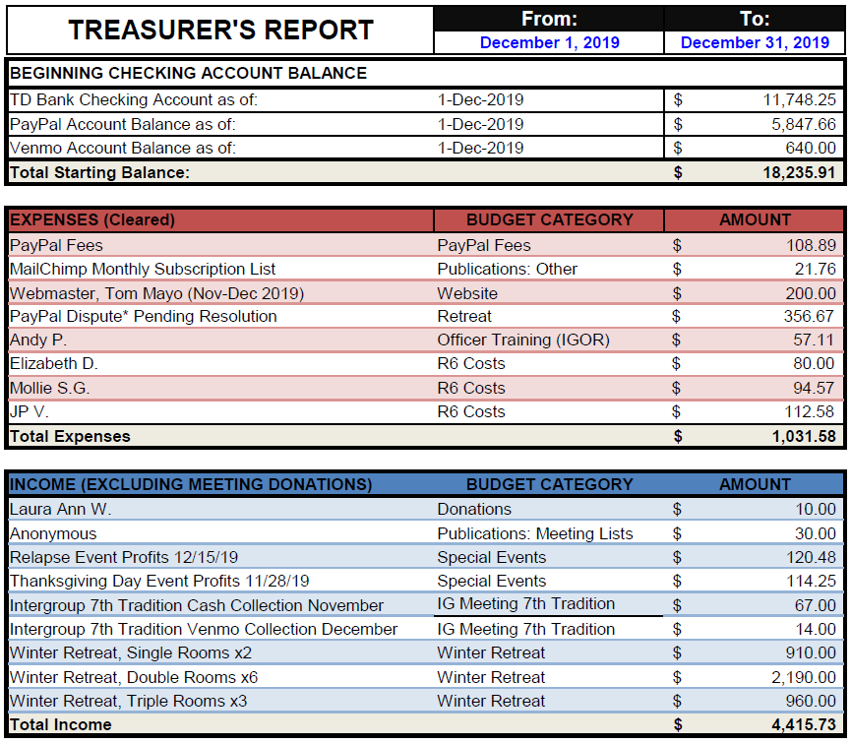

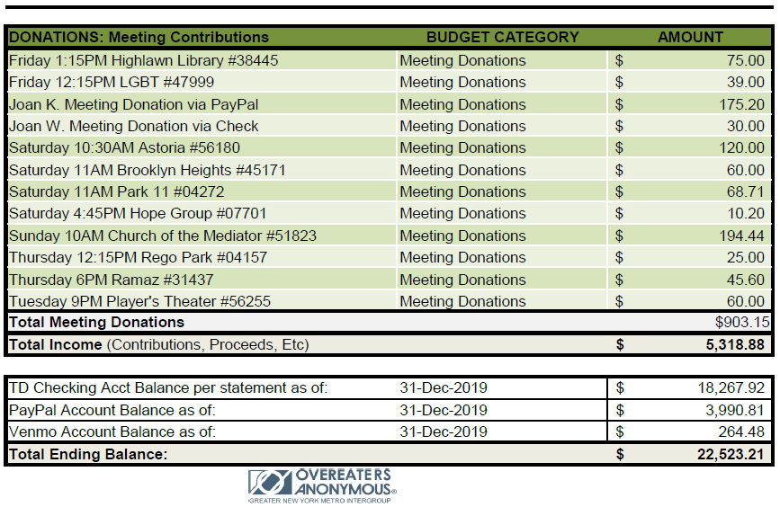

Publications Committee Chair Report/Hannah P: The publications committee sent out reminders for the New Year's Day Marathon and distributed the PDF of the December Metro Memo. There was an open rate of 30% for the Marathon and 34% for the Metro Memo, which is in line with what we have seen before.
The meeting list is constantly being updated with new submissions and corrections, so thank you to those who work on the online and PDF meeting lists.
We will be sending out the January Metro Memo on Friday, January 10. We will also continue to create reminders for all of the special events!
The publications committee would love your submissions, artwork, or games to include in the digital and hard copy Metro Memos! Please contact publications@oanyc.org to get involved!

Special Events Committee Report/Erin B: The committee held events every 2 weeks over the holidays. Our last 2 events were the Relapse from Recovery event on Sunday, December 15th and the New Year's Day Marathon at 4thU Church. Both events were successful. There were 40-50 people at each meeting/event. We netted $370 from these last 2 events.
Our next event will be in February along the lines of Valentine's Day - Sex & Love in Recovery: Practicing the Traditions in Bed! On February 23rd from 2:30pm-4:30pm at the Fourth Universalist Society on 76th and Central Park West.
Following this will be a Spring Cleaning event on April 16th, 2pm-5pm at 4thU - A Recovery Clothing Swap for all genders and all sizes! Bring your gently used clothing and accessories and we'll donate anything not taken!
Both upcoming events are listed on oa.org and oanyc.org.
These 2 events will be planned at our next virtual Special Events Committee meeting on Tuesday, January 21st @ 5pm. Email specialevents@oanyc.org if you'd like to attend virtually!

Web Committee Chair Report/Liz D: This month the web committee did it's standard work (updating the site with meeting changes, special events, intergroup minutes, and posting the new meeting list). We also welcomed a fellow to the committee who will be helping to learn more about how the website works and documenting processes for institutional knowledge. The committee will also work to identify ways to make the site more user friendly.
Last month one of our goals was to get the calendar fixed and we have done that. It has all event info up to date.
Also this month we began receiving weekly google analytics info which is very interesting. The chair is learning how people are getting to our site and what pages they are looking at, amongst other things.
This month we will continue with our goal of fixing the logo on our mobile site and the buttons for our meeting minutes. The other goal for this month is to get the retreat info taken down as soon as the retreat is over.
Please contact the web committee if you want info posted or if you would like to join the committee.

Outreach Committee Chair Report/Mollie S: This month the committee met and discussed the next steps for launching the google ads and ideas for other outreach events such as health fairs in communities that are under-represented in OA. We also finalized our budget for the google ads and reached out to the IG board about the approval process for specific text ads we have proposed. In addition, we spoke with the webmaster (Tom Mayo) and arranged to receive weekly reports of the Google analytics. Using these analytics we have established a baseline for the current traffic on our webpage and will use this information to determine how effective the Google ads are once we launch them.
Next month we plan to launch the google ads and will choose other outreach events to pursue. If you’d like to get involved in outreach or have any questions please email outreach@oanyc.org.

Retreat Committee Chair Report/Barbara S: Registration seems to have picked up in the past few weeks. We now have 47 registrants with a few more people indicating interest who have yet to sign up. All fellows who will be speaking have been informed of their assignments, and service assignments were sent out this week. The final payment for both the Guest House & bus contracts have been paid.

