Meeting is called to order at 6:48 pm and we begin with the serenity prayer. Andrea F. reads and reviews the 10th Tradition. Andy P. reads and reviews the 10th Concept. Reps go around the room and introduce themselves.

There were:
- 5 new IG members
- 22 Attendees at peak
- 20 voting members
- 3 Board members

A quorum is established.

Minutes

Sean notifies Intergroup that we will vote on September minutes during New Business.

Committee Reports

#1: Sean appoints Hannah P. as the Publications Chair.
#2: Andy gives Finance Committee Chair Report (attached)
#3: Erin gives a Special Events Committee Chair Report (attached)
#4: Barbara gives Retreat Committee Chair Report (attached)
#5: Rebecca gives a 12th Step Within Committee Chair Report
#6: Sarah WB gives a Web Committee Chair Report (attached)
#7: JP gives a Bylaws Committee Chair Report

Pending Business

#1: Andy gives an IGOR officer training report and suggests that we create “locally produced” literature from fellows in NYC and that produce an end of year report to share where contributions to Intergroup are going.
#2: Scott, Erin, Jeff and JP give Fall 2019 Region Assembly reports.
#3: There is an existing (tabled) motion from Marsha that we apply for a Google Ads grant which could provide up to a $10,000 credit. Andy gives an update on the status of the Google Ads Grant application process and that according to World Service receiving an ads grant from Google is not a 7th tradition break. We cannot review the full application in advance given Google’s process. A fellow expresses concern that when something is given for free (in this instance, the potential grant from Google), our information could be for sale. Another fellow suggests that Marsha fills out the application and takes screenshots of each page so that the board and Intergroup can review it in full before it’s submitted. Sean takes 3 pros and 3 cons. A motion is made to table the motion until Marsha is present at Intergroup to answer questions. 13 in favor. 5 opposed. 2 abstentions. The motion carries.
#4: Sean announces that Region 6 is looking for volunteers at the Region 6 convention. The Region 6 convention will take place from Friday October 18th through Sunday October 20th in White Plains.
#5: The 7th Tradition is collected.

New Business

#1: Sean makes a motion to accept the September minutes. An amendment to the minutes is made. Scott seconds the motion to accept the amended minutes. The motion carries.
#2: JP shares a highlighted document, the “Unite with Diversity” pamphlet from oa.org.
#3: Sean volunteers to share a highlighted document from oa.org in November.
#4: Andrea F. and Mike H. agree to be our Google Voice volunteers.
#5: JP agrees to read 11th Tradition.
#6: David W. agrees to read 11th Concept.

Announcements

#1: Andy announces that we have collected in $59 in cash 7th tradition contributions.
#2: Sean reminds Intergroup that there is no abstinence requirement to join a committee and our committees need support.

Wrapping Up
Meeting closes at 8:03 pm with the OA pledge and the serenity prayer.
Committee Reports:

Position | Person | Email Contact
Chair | Sean B. | Chair@oanyc.org
Vice Chair | Sarah WB | ViceChair@oanyc.org
Treasurer & Finance | Sunny W. | Finance@oanyc.org  Treasurer@oanyc.org
Corresponding Secretary | Andy P. | CorrespondingSecretary@oanyc.org
Recording Secretary | Heather M. | RecordingSecretary@oanyc.org
Archives Committee Chair | OPEN | Archives@oanyc.org
Bylaws Committee Chair | JP M. | Bylaws@oanyc.org
Outreach Committee Chair | Mollie S-G | Outreach@oanyc.org
Publications Committee Chair | Hannah P. | Publications@oanyc.org
Retreat Committee Chair | Barbara S. | Retreat@oanyc.org
Special Events Committee Chair | Erin B. | SpecialEvents@oanyc.org
12th Step Within Committee Chair | Rebecca B. | TwelfthStepWithin@oanyc.org
Web Committee Chair | Liz D. | WebCoordinator@oanyc.org
3 Year Trustee | Andy P. | ThreeYearTrustee@oanyc.org
1-Year Trustee A: | Rebecca B | OneYearTrustee@oanyc.org
1-Year Trustee B: | Mollie S-G | OneYearTrustee@oanyc.org

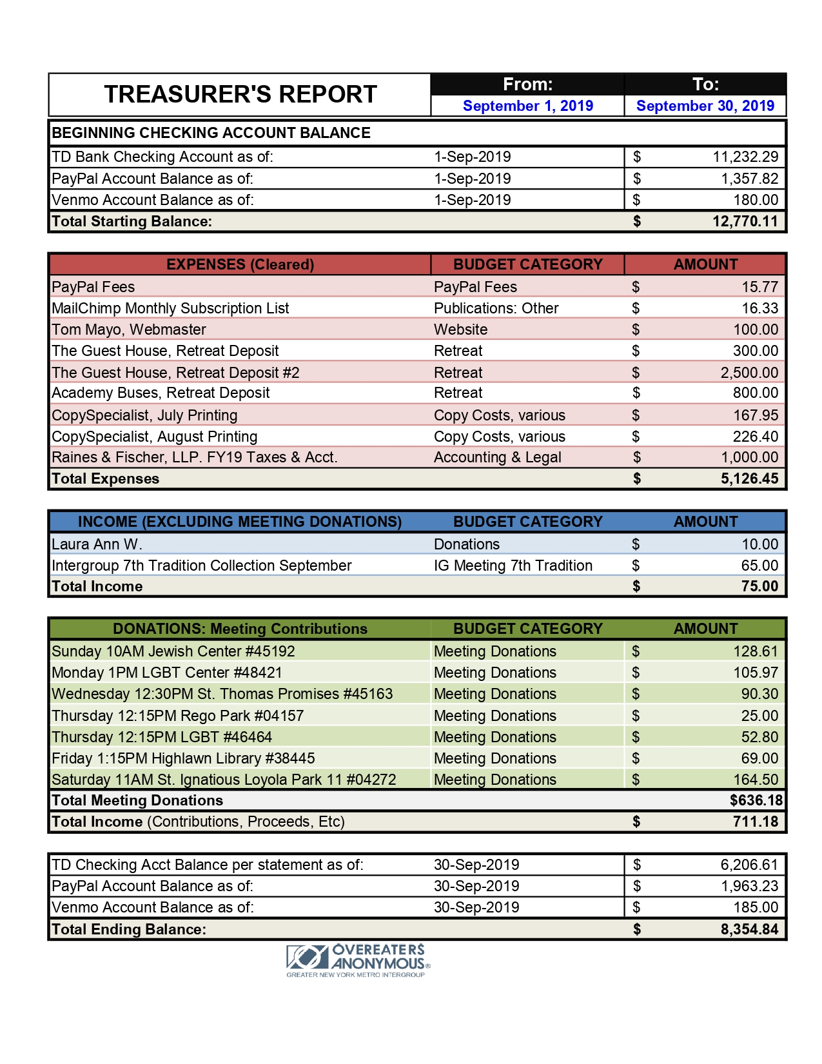
Special Events Committee Chair Report/Erin B: On September 29th, we held a successful Sponsorship 101 Workshop! We had about 30 attendees, 2 speaker panels, ask-it-baskets, a slogan wall, breakout groups, 1-on-1 practice sessions and a 20-person Sponsorship Speed Dating! We made $81 in profit.
The next event is being planned on IDEA Day on Saturday, November 16th from 1pm-3pm at 4 W. 76th St in the gym. This event will include a focus on Plans of Eating as a tool, Abstinence as defined by World Service, a Qualification, a Food Prep table, an OA Timeline and many interactive & performance activities! Please attend!
We've had a difficult time finding a location for our Thanksgiving Day Marathon. It will be held from 10am-2pm with four 1-hour meetings. Each meeting will have a different format and a different qualification. Please use this opportunity to stay grounded on what can be a most challenging day for us compulsive overeaters.

Web Committee Chair Report/Liz D: The committee has a new member who will be taking on some tasks and work with the chair on documenting web processes. The committee has posted meeting updates and changes and worked on other issues on the site (fixing links, for example). The Meeting Minutes are available and up to date from the Meeting Info tab on the home page under “Metro Intergroup Monthly Meeting Minutes.” I have been looking for them, and perhaps others have too, under the Intergroup info section and then clicking on the meeting minutes button. There is an ongoing problem on the meeting minutes page which is currently displaying “That page can't be found” message. The webmaster is working on this. A heuristic evaluation of the site will be done; I will work with Tom and our new committee member to get this underway. This is a process that can help ensure that information is easily found on the site. For now I will see if Tom can make the info available from each place on the site. Please tell fellows at your meetings to let us know about any web related issues. They can email the web committee at webcoordiantor@oanyc.org.

Retreat Committee Chair Report/Barbara S: All contracts have been signed and initial payments made, including those for The Guest House & for the two bus trips—up to & back from Chester, CT. The retreat committee has completed work on the brochure, which has been approved by the IG Board & is ready to distribute at your meetings. We are working with the webmaster to have the online registration for the retreat go live on Monday, 10/14. To help those OA members who want to attend the retreat but cannot afford to do so, there will be a “scholarship fund” set up. People may contribute to this fund as part of the registration process. Also, since registration is non-refundable, we will also make it possible for people to donate their room if they have to cancel and cannot find someone to replace them.

