Meeting is called to order at 6:47pm and we begin with the serenity prayer. Debora reads and reviews the 9th Tradition. Sean reads and reviews the 9th Concept. Reps go around the room and introduce themselves.

There were:
- 1 new IG member - Marcy
- 17 Attendees at peak
- 15 voting members
- 3 Board members

A quorum is established.

Minutes

Sean notifies Intergroup that we will vote on August minutes during New Business.

Committee Reports

#1 Sean appoints Barbara S. as the Retreat Chair.
#2 Andy gives a Finance Committee Chair Report (attached)
#3 Erin gives a Special Events Committee Chair Report (attached)
#4 Barbara gives Retreat Committee Chair Report
#5 Rebecca gives a 12th Step Within Committee Chair Report
#6 Liz gives a Web Committee Chair Report (attached)
#7 JP gives a Bylaws Committee Chair Report (attached)

Pending Business

#1: Sean announces the Open Chair Position: Publications
#2: Marsha reviews the digital marketing proposal. The floor is opened for discussion. Marsha moves to add Google Analytics to the oanyc.org website with the expectation to anonymize the IP addresses of visitors (masking the view from OA members but not from Google) as well as setting up Google Ads for oanyc.org.
The motion passes with 12 yay votes and 3 abstentions.
Marsha makes a motion that we apply for a Google Ads Grant from Google for Nonprofits for up to a $10,000 credit.
Andrea moves to table the motion until the Tradition 7 concern is reviewed with the Region 6 Trustee.
Erin moves to amend Andrea’s motion to include the acquisition of the Google Ad Grant application for review before Marsha’s motion is voted on.
Erin’s amendment carries.
Andrea’s motion carries.
Original motion is tabled.
#3 Sean announces Region 6 convention is looking for volunteers for service.
#4 The 7th Tradition is collected.

New Business

#1: Sean makes a motion to accept the August minutes. Erin seconds the motion. August minutes are approved.
#2 JP makes a motion to add Policy 018 to the bylaws to formalize donation amounts from Metro Intergroup to WSBC and Region 6 in the By Laws. Motion passes unanimously.
#3 Jennifer shares a highlighted document “Carrying The Message”
#4 JP volunteers to share a highlighted document from OA.org
#5 Debora and Belen agree to be our Google Voice volunteers.
#6 Andrea agrees to read 10th Tradition.
#7 Andy agrees to read 10th Concept.

Announcements

#1: Sean announces that we have collected in $60.00 in 7th tradition contributions.
#2: Barbara questioned her role in the decision making process for the retreat. The chair determined that the questions should be discussed directly with the board.

Wrapping Up
Meeting closes at 8:18 pm with the OA pledge and the serenity prayer.
Committee Reports:

Position | Person | Email Contact
Chair | Sean B. | Chair@oanyc.org
Vice Chair | Sarah W. B. | ViceChair@oanyc.org
Treasurer & Finance | Sunny W. | Finance@oanyc.org  Treasurer@oanyc.org
Corresponding Secretary | Andy P. | CorrespondingSecretary@oanyc.org
Recording Secretary | Heather M. | RecordingSecretary@oanyc.org
Archives Committee Chair | OPEN | Archives@oanyc.org
Bylaws Committee Chair | JP M. | Bylaws@oanyc.org
Outreach Committee Chair | Mollie S-G | Outreach@oanyc.org
Publications Committee Chair | OPEN | Publications@oanyc.org
Retreat Committee Chair | Barbara S. | Retreat@oanyc.org
Special Events Committee Chair | Erin B. | SpecialEvents@oanyc.org
12th Step Within Committee Chair | Rebecca B. | TwelfthStepWithin@oanyc.org
Web Committee Chair | Liz D. | WebCoordinator@oanyc.org
3 Year Trustee | Andy P. | ThreeYearTrustee@oanyc.org
1-Year Trustee A: | Rebecca B | OneYearTrustee@oanyc.org
1-Year Trustee B: | Mollie S-G | OneYearTrustee@oanyc.org

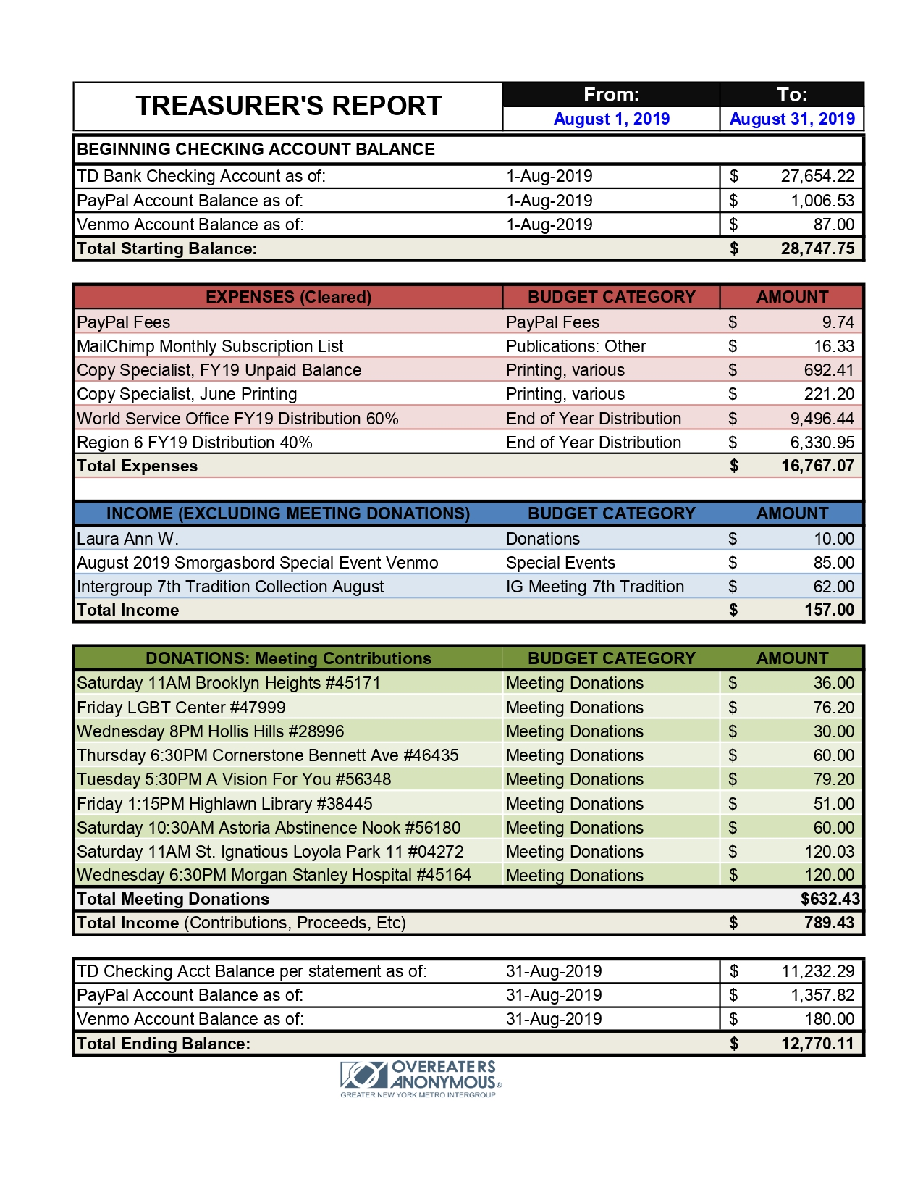

Special Events Committee Chair Report/Erin B: The OA Smorgasbord on Aug 18th was a great success. We brought in $393. After the rent and water bottles were paid, we netted $333. The event wrapped an hour early due to bad weather, dwindling attendance and a double-booking of a large AA meeting.
The Special Events Committee has two upcoming events planned. The Sponsorship 101 Workshop on Sept. 29th from 2:30pm - 5:00pm. That workshop will include a sponsor panel, a sponsee panel, a slogan wall, breakout groups, 1-on-1 practice sessions, Sponsorship-Speed-Dating and raffle prizes! We’re still looking for support with the door table, set-up and simple clean-up!
The event following will be held on OA’s IDEA Day (International Day of Experiencing Abstinence). It will be an Abstinence and Plan of Eating Workshop on November 16th from 1pm-3pm. This workshop will include a history of OA, the difference between Abstinence and the Plan of Eating tool, food prep suggestions, breakout groups, qualifications and more raffle prizes!!
Two weeks later will be the Thanksgiving Day Marathon!
All Special Events this year are being held at The Fourth Universalist Society, 4 W. 76th St. (This location is not ADA accessible and parking is limited.)
Our next virtual committee meeting will be held at 5pm online on Sept. 17th. All are welcome. We will plan the November events.

Bylaws Committee/JP: The Bylaws committee prepared a proposed change to Policy 018 for consideration at the September IG meeting.

POLICY NUMBER: 018 ORIGINALLY PASSED: 4/92
DELETION DATE: 11/11

Donations to Other Overeaters Anonymous Service Groups

POLICY
Monies specified by member groups to be sent to WSO or to Region Six shall not be counted as part of Metro Intergroup's monies.

The Treasurer shall keep separate records for those monies allocated by groups for WSO and to Region Six.
___________________________________________________________________________________

Suggested change:

POLICY NUMBER: 018 ORIGINALLY PASSED: 4/92
DELETION DATE: 11/11
REVISION DATE: 9/19

Donations to Other Overeaters Anonymous Service Groups

POLICY

After the end of each fiscal year, Metro Intergroup will donate excess funds to WSO and Region 6
PROCEDURE
Upon closing the books at the end of the fiscal year, the Treasurer will determine the prudent reserve for the coming fiscal year, the expected expenses for the first month, and, if a retreat is scheduled that has already had money come in for participation, the accrued revenue less expenses for the upcoming retreat. The treasurer will add these amounts up and any money above the total will be donated to WSO and Region 6 within a split range of 60-75% to WSO and 25-40% for Region 6 such that the total percentage is 100%. The split will be suggested by the finance committee and voted upon by the Intergroup.

Web Committee/Liz D: In September, the web committee made good progress getting up event advertisements and learning more functionality. Thank you to all the fellows for their patience and guidance on web related stuff. FYI, there is a bug with posting minutes right now that the webmaster is working on. Currently, minutes cannot be uploaded at all.

