Sarah WB calls the meeting to order at 6:45pm and we begin with the serenity prayer. Liz D. reads and reviews the 11th Tradition. Andrea reads and reviews the 11th Concept. Reps go around the room and introduce themselves.

There were:
- 5 new IG members
- 24 Attendees at peak
- 20 voting members
- 4 Board members

A quorum is established.

Minutes

Sarah notifies Intergroup that we will vote on October minutes during New Business.

Committee Reports

#1: Sunny gives the Finance Committee Chair Report (attached)
#2: Erin gives the Special Events Committee Chair Report (attached). Diana brought up concerns with the “food prep” table at the Idea Day event. The board and trustees will discuss after the meeting.
#3: Barbara gives Retreat Committee Chair Report (attached)
#4: Mollie gives the Outreach Committee Chair Report (attached)
#5: Erin gives the 12th Step Within Committee Chair Report
#6: Hannah gives a Publication Committee Chair Report (attached)
#7: Liz gives the Web Committee Chair Report (attached)
#8: JP gives the Bylaws Committee Chair Report

Pending Business

#1: There is an existing (tabled) motion from Marsha that we apply for a Google Ads grant which could provide up to a $10,000 credit. Andy gives an update on the status of the Google Ads Grant. According to a World Service trustee, when a World Service audit was done it was determined that an ads grant from Google would go against the World Service bylaws. Sean and Andy spoke with Metro IG’s accountant who stated that the grant would need to be accounted for as either a donation or income. Andrea expresses concerns that if World Service determined a Google Ad Grant went against their bylaws it would also be against Metro IG’s.
A vote is taken on the tabled motion that we apply for a Google Ads Grant from Google for Nonprofits for up to a $10,000 credit. 0 in favor. 18 opposed. 1 abstention. The motion fails.
#2: The 7th Tradition is collected.

New Business

#1: Sunny makes a motion to accept the October minutes. Scott seconds the motion. October minutes are approved.
#2: Sunny goes over proposed amendments to the current budget. Sunny makes a motion to make the proposed amendments to the budget. The motion is seconded by JP. 3 pros and 2 cons are heard. A vote is called. 19 in favor. 1 opposed. The motion carries.
#3: Sean will share a highlighted oa.org document “Website Development Guidelines” in December.
#4: Sasha and Phil agree to be our Google Voice volunteers.
#5: JP agrees to read 12th Tradition.
#6: Erin agrees to read 12th Concept.

Announcements

#1: Scott announces that we have collected in $67.00 in 7th tradition contributions. Sunny confirms.
#2: Sarah reminds Intergroup that there is no abstinence requirement to join a committee and our committees need support.
#3: JP has OA literature for purchase. Please see him after the meeting if you are interested.

Wrapping Up
Meeting closes at 8:18 pm with the OA pledge and the serenity prayer.
Committee Reports:

Position | Person | Email Contact
Chair | Sean B. | Chair@oanyc.org
Vice Chair | Sarah WB | ViceChair@oanyc.org
Treasurer & Finance | Sunny W. | Finance@oanyc.org  Treasurer@oanyc.org
Corresponding Secretary | Andy P. | CorrespondingSecretary@oanyc.org
Recording Secretary | Heather M. | RecordingSecretary@oanyc.org
Archives Committee Chair | OPEN | Archives@oanyc.org
Bylaws Committee Chair | JP M. | Bylaws@oanyc.org
Outreach Committee Chair | Mollie S-G | Outreach@oanyc.org
Publications Committee Chair | Hannah P. | Publications@oanyc.org
Retreat Committee Chair | Barbara S. | Retreat@oanyc.org
Special Events Committee Chair | Erin B. | SpecialEvents@oanyc.org
12th Step Within Committee Chair | Rebecca B. | TwelfthStepWithin@oanyc.org
Web Committee Chair | Liz D. | WebCoordinator@oanyc.org
3 Year Trustee | Andy P. | ThreeYearTrustee@oanyc.org
1-Year Trustee A: | Rebecca B | OneYearTrustee@oanyc.org
1-Year Trustee B: | Mollie S-G | OneYearTrustee@oanyc.org
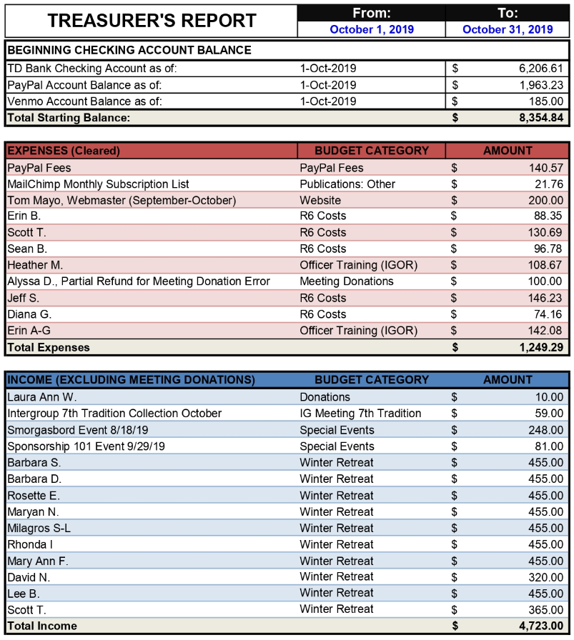
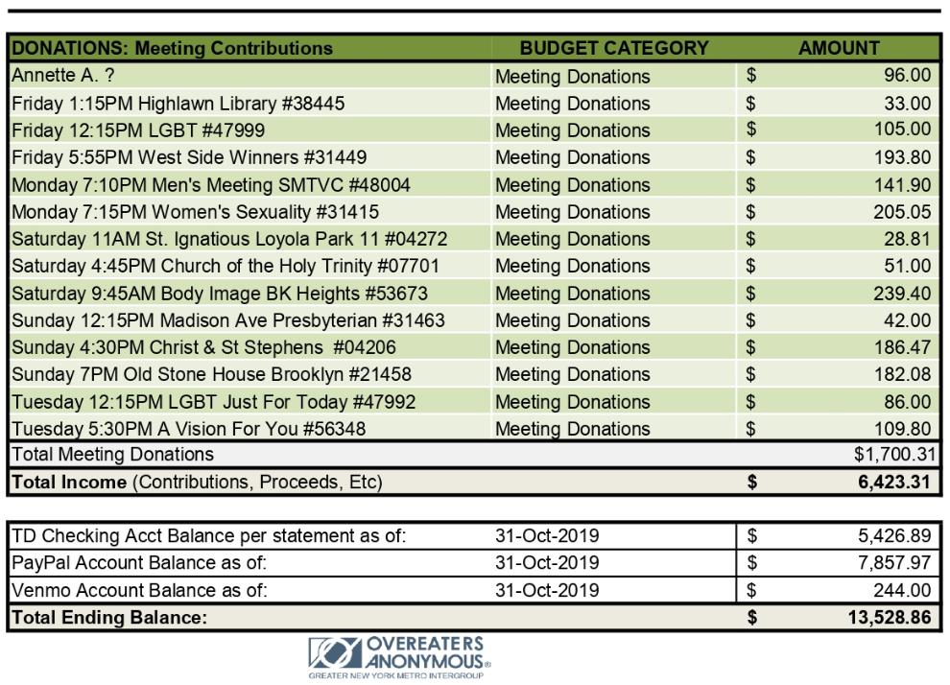

Special Events Committee Report/Erin B: The committee is doubling up on events over the holidays! At the last committee meeting, it was decided to put together an OA Timeline for the next event. This does not currently exist, but many resources are coming together to make an interactive wall timeline! The next event will be on Saturday, Nov. 16th 1-3pm at 4thU Church on IDEA Day (OA's holiday - International Day of Experiencing Abstinence) with a theme of Abstinence vs. Plan of Eating. We will have a great qualification, a Food Prep table, a writing exercise, lots of sharing time, and an awesome interactive exercise involving OA's favorite activity...skits!
Thanks to Debbie, we have a location for the Thanksgiving Day Marathon!! November 28th 10am-2pm at Kehilath Jeshurun, 125 E 85th St. We will have four 1-hour meetings back-to-back with 4 different speakers. Debbie will be there for the first hour, but we're still looking for support to handle 11am-2pm. The only responsibility will be to establish a chair for the meeting. The last speaker will collect the total 7th Tradition cash. Any takers?? Please email specialevents@oanyc.org.
Because the holidays are hard for us OA-ers, we'll be holding a Relapse from Recovery event on Sunday, December 15th from 2:30pm-4:30pm at the 4thU church. We will have great speakers, fantastic OA handouts for handling the holidays and lots of support from fellows. This event will be planned at our next virtual Special Events Committee meeting on Tuesday, November 19th @ 5pm. Email specialevents@oanyc.org if you'd like to attend virtually!

Publications Committee Chair Report/Hannah P: Publications has put together the email campaigns to publicize the IDEA Day workshops and Thanksgiving Marathons. The meeting lists are also being continuously updated. This month, we will put out a digital copy of the Metro Memo, with a goal of Friday, November 15.
In order to make sure the blasts reach as many fellows as possible, please encourage fellows to sign up on OANYC.org.

Web Committee Chair Report/Liz D: The basics of the website upkeep were done in the month of October. The meeting alerts, google voice, and banners were all successfully completed.
One item of note for the board, it was brought to the web committee’s attention that there is registration information in the bluehost site that may be outdated, it has someone named Devyn's information. It has been suggested that the board discuss this before anything is changed. Also, there is a question about what card should be listed on the auto-renew section so I am bringing that to the board's attention. The Thanksgiving marathon has been given its own tab on the website while the slider continues to be worked on by Tom. He is considering using a new slider if he can't fix the current one.
Congratulations to the Retreat chair, committee and Tom for getting the info updated and easily accessible on the site.
The committee also identify some nonworking items on the site and is working with Tom to remedy these issues. One is the calendar, which was updated but now is not visible. The second issues is where the meeting minutes are hosted. The minutes are nested under meeting info but when you look on the Intergroup tab there is a button for meeting minutes which just says "that page cannot be found. So good that the minutes are accessible and that we have identified this problem. It will continue to be worked on.

Retreat Committee Chair Report/Barbara S: Retreat registration opened on the oanyc.org website October 15. So far we have received 11 registrations, one of which is for a triple, but only 1 of the 3 people sharing this room have registered to date. We are currently having some problems with the registration process which I'm working on with the webmaster & hope to have resolved soon. The retreat committee will resume our meetings after we have received more registrations since the next steps involve assigning rooms, and speaking and service assignments.

Outreach Committee Chair Report/Mollie S: This month the Outreach Committee has worked with the Intergroup board to look into the feasibility of applying for a Google grant as a nonprofit organization to fund the Google Ads. The committee has also looked into alternative sources of funding the Google Ads, including the Region6 PIPO Blitz fund. In addition, the contact person for a meeting reached out to the committee because they received a call from a person who was homebound due to their weight and desperately wanted an outreach call from a fellow who could relate. The committee got in touch with a fellow who was willing to call them. Next month the Outreach Committee will work on the application for the PIPO Blitz Fund and continue to look into whether the Google grant is an appropriate source of funding.
If you would like to get involved with the outreach committee please email outreach@oanyc.org.

